**Smart Road Trip Planner : Personalized Trip Planning by Capturing User Interactions**

Rishi Dinesh, Pranav Balaji, Kanagha Santhoshini, Manasa Y K

**Abstract**

The goal of this project is to build a web application that can act as a one-stop solution for its users by allowing them to plan all aspects of a road trip with ease and comfort. This system will be powered by numerous APIs thereby integrating all the essential information and functions needed for travel planning within a single piece of software.

This project will be designed to incorporate many of the core functionalities usually found separately in other applications. These include a route calculator that provides an optimal route by accounting for the various points of interest along the way and other functions that can meet the accommodation, food, drinks and other recreational requirements of the user.

Unlike other trip planning websites, this system is unique in the sense that we aim to capture the user’s interest and mindset and personalize the website experience using Machine Learning models. The entire application will be backed by an AI that will act as a virtual assistant to guide the user in the trip planning process by providing inspiration to travel and providing recommendations for hotels and other places of interest.

In addition to this, the website will also feature a blog section where users can read and share travel blogs and itineraries. This blog section too, like the rest of the website, will be built to capture the user’s likes and interests.

*Keywords: Trip planning, Planning functionalities, Recommender Systems, Personalization*

**Introduction**

A road trip planner is a system which would help one to plan a road trip, i.e. a long journey between two spots travelled by road in vehicles such as cars, RVs, etc. In a regular road trip planner one might find an option to enter the to and from locations and have the route mapped out in addition to certain other features such as fuel stations along the route, etc. A regular city itinerary planner is a software that, as the name suggests, provides an itinerary of sightseeing locations across a city. In this project we have attempted to create an amalgamation of a smart road trip planner, in that it has multiple additional features and a recommendation software, a city sightseeing itinerary planner and a blog section to tie these together. In the report below we explore the several journals we went through to understand the project, the various algorithms and approaches others have used to achieve similar results or related applications and a detailed explanation of our approach to this idea along with necessary diagrams.

**Literature Survey**

Choosing what places to visit and what not to visit is a problem that many tourists face. It usually is not possible to visit every tourist attraction in a particular place, and hence, the tourist must filter what he/she thinks to be the most valuable Points of Interest (POI). This selection is based on advertisements, offers, experiences, etc. A trip planning algorithm to solve this problem must also approach the problem in a similar way. The model must consider temporal information – such as museum exhibits that change every day, and many more, to provide appropriate recommendations. Generic tour planning does not take the user context into consideration.

[1] deals with the analysis and breakdown of different models of trip planning along with POI (Points of Interest) and lodging recommendations. It demonstrates the usefulness of different existing models from the field of “Operations Research” (OR) in dealing with this scheduling problem. It also deals with using the “Orienteering Problem” (OP) and its extensions to optimize the solution.

Optimality and Personalization are the key mantras to the perfect model. Web-based recommenders are excellent when used in conjunction with a user interest profile and up-to-date POI information. This will help to spread tourists more evenly and prevent crowds.

Various strategies were developed in order to tackle this problem. [2] developed a software agent that recommends a trip plan using conversation with the user. [3] present Interactive TouRist Information GUidE (INTRIGUE), a fuzzy logic-based recommender system with capabilities for prediction recognition. [4] presented a multiagent system that advises personalist travel routes using a vector-based recommendation technique to calculate Personal Interest of POIs.[5] presented P-Tour, a personal navigation device that calculated tourist routes. It maximizes travel costs minus collected profit. [6] present Dynamic Tour Guide (DTG), which calculates personal tours on the fly. Constructed using Tour Building Blocks (TBB), made using Interest Matching Points by a semantic algorithm. [7] present a recommendation system that allows planning personalized travel routes in China. It consists of a context-decision agent which matches concepts of ontology to the user’s requirements. It then uses fuzzy logic to find a solution to the TSP. [8] developed a method for personalizing route planning network impedances. Personal preference points are attached to weights of the path, which can later be solved using Dijkstra’s or A* algorithm.

[1] developed a number of planning functionalities that could help in tourist decision support. The paper then proceeds to evaluate every strategy mentioned before to these functionalities and presents a table of the provided functionalities.

[9] is a web-based system for facilitating the travel planning process, implemented using a variety of travel planning APIs. Unlike other applications which basically calendarize planning, this application encompasses a variety of functionality under a single shell. These functionalities include hotel reservation, calculating optimum routes from start to destination, etc. all while making sure to follow user requirements and preferences for dining, relaxation, and sleep. Moreover, these services are not limited to the city discussed in this paper.

This application is developed as a direct solution towards increasing globalization that has been accompanied by local international travel. Although a variety of travel options are available, people still face difficulties in building a proper plan for their trip.

This application is developed using a wide variety of APIs and mashups and services from the internet. Unlike other applications, this system integrates a lot of the features under a single software unit. Some features include user preference-based recommendation, blocking time slots in between plans and many more. This system is not limited to a specific location and can be expanded to any area with Google Maps and the corresponding API’s services.

Several applications have come together to access and collect data from light-weight APIs and provide consolidated services in the form of *mashups*. These applications have also surfaced in the field of travel planning. One well known example is *Expedia*, which offers localized travel websites for 29 countries and allows users to book airline tickets and make hotel reservations. *Yahoo Travel!* is another prominent website which offers similar features. *TripIt* and *TravelTracker* are iOS applications that help users with travel planning.

Apart from these applications, several researchers are also actively working in this area to come up with innovative solutions. Examples include the *STAAR (Semantic Tourist Information, Access, and Recommendation)*, an ontology-based system that handles semantically and geographically enriched data. It also incorporates an algorithm for recommending travel-routes using itinerary length and user interests. One thing to note in all these applications is that none of them provide an option for the user to set aside free/personal time in between travels.

The application is a mashup of the following APIs: Google Maps API, Google Places API, Wikipedia API and Expedia API. Route calculation is using a modified Dijkstra’s algorithm. Database security issues of storing place data from Google APIs are handled, requests to Expedia are handled efficiently and rationally and many more issues had to be resolved efficiently.

This application handles the overwhelming data that is required in planning a trip by providing a lot of features and functionalities in a single software frame. It leverages the use of multiple APIs to gather and process data.

Some future works include adding additional functionality to the system like providing on-site hotel reservation service, transport rental service, mobile alerts for checkpoints, optimization of the route calculation function by including weather and traffic conditions, usage of semantic web technologies to better suit user preferences and exporting to a mobile platform.

[10] is a survey that divides the tourist life cycles into 3 phases: pre-trip, on-trip and post-trip. *Pre-trip* includes trip preparations like accommodation, tickets and planning site visits etc. *On-trip* includes tools that provide Ad-hoc tourism information while on trip, navigation and other contextual information about weather, location, time and POIs. *Post-trip* includes tools that give users capabilities to present tourist feedback and experience sharing.

The main job is considered to be planning individual visits and preparing a trip itinerary while taking into account individual preferences of tourists.

Thus, the main contribution of this paper includes a comprehensive investigation of 4 representative trip planners wherein the evaluation is done by utilizing criteria catalogs of functionalities drawn by literature reviews. Another contribution deals with areas of further improvement in the already existing systems.

It presents the state-of-the-art tourist trip planning systems at the moment based on a feature evaluation framework comprising common criteria, planning functionalities and customization level. It focuses on showing the difference between existing planners and points out possible improvements. It concludes that the evaluated systems employ a rich feature set for trip planning starting from different options for POI selection, up to the advanced features wherein group tours and re-planning remain an open field for research.

In one of the closely related surveys [14], comparison on existing tour scheduling approaches is made which outlines the lack of support for scenic routes, hotel selections, public transportations and group profiles. Additional comparison functionalities like navigation, identification of objects at a spot, offline support etc are added. [15] Using another survey, evaluation of 4 representative mobile tourists is done comparing their abilities on the basis of provision of POIs, weather details, security, news etc when on field.

[11] is a study that attempts to produce empirical findings about the nature of travel decision making that has been addressed by researchers skeptical about conventional approaches. It also expands this model to a more comprehensive framework by including tourists’ information use patterns across the different stages of the travel planning process.

From a study based on the relationship between planning time and some explanatory variables, it was concluded that there exists a pattern of stable behaviors in the leisure travel planning process. Further, another study revealed that the structure of the trip decision-making was contingent and hierarchical in nature, where decisions made at an early stage appear to condition the decisions made in later stages.

The aim of this study is to provide evidence for an alternative view to decision making along with examining the information use patterns across different stages of the decision-making process. The study calls for further effort in examining tourist’s information use behavior at different facets of the complex travel decision-making process in different cultural, situational and destination contexts. A further area for improvement is to implement a more rigorous sampling procedure to take into account nonresponse bias and seasonal variations.

[12] is a project where they set out to make the process of planning a trip less tedious, more transparent, and more suited for the spontaneity of the current generation. This paper reports an exploratory study of using Google Map API to develop two destination specific tourist information tools, a handheld device similar to that of a mobile phone to function as a tour guide and an online trip planner for Charleston, South Carolina, USA.

Since the Geographical Information System (GIS) has been adopted widely in tourism, online GIS tools can be used to access large amounts of geographical information. The Google Maps Application Program Interface (API) is a free service available to anyone and) allows a programmer to embed Google Maps in his/her own web pages with JavaScript. Global Positioning System (GPS) based systems becoming more affordable was also an incentive for them to use those.

Several theories have pointed to the power of map metaphor and mapping interface, and they have utilized this here. They hypothesize that location-based information trip planning and on-route and during-trip information providence could help the visitors build cognitive maps quicker and more detailed leading to the visitors being more engaged, visit more attractions, spend more on food and entertainments, achieve a higher satisfaction, and become more loyal customers. The goal of their proposed project was to build and test two web-based tools: a GPS-enabled handheld information device for the visitors to tour downtown Charleston and an online interactive trip planning tool for the same. The former would provide visitors with location-sensitive texts, images, audios, and videos based on their actual physical locations; the latter would help visitors plan their trips to Charleston using an interactive map prior to their departure or in their hotel rooms.

Various tourist attractions, accommodations, and dining places retrieved from the travel council database, which is built in the first development project for the handheld tour guide, in which the visitors can add their itinerary and they show up on the map. When multiple addresses are added, directions between those locations will be automatically displayed. They will also be able to rearrange the locations and set a default starting point. The program uses cookies to track the user session.

The aim of [13] was to create an easier way to plan trips (itinerary recommendation) with the places of interest (POI) being recommended being specifically tailored for each person. They start off with retrieving visitor data by mining tourist trajectories using geo-tagged photos (constructing an ordered sequence of relevant photos mapping, photos to popular POIs, and generating timed sequences of POI visits), mining tourist visits on location-based social networks and GPS-based trajectory traces. Tour itineraries recommendation has its roots in Orienteering Problem (OP), and Tour Recommendation with Category Visit Constraints is similar to OP except that it considers the POI categories in their tour recommendation and recommend tours with a specific visit order over all POI categories along with a way to balance out the “sensory overload” with the Cluster Itinerary Planning (CLIP) algorithm that aims to recommend tour itineraries with constraints on the maximum number of times that each POI category can be recommended.

To personalize the recommendations, they used the factors of age, gender and race and also considered TripBuilder Algorithm, TourRecInt Algorithm, PersTour Algorithm, Aurigo System, Photo2 Trip System, Context-aware Tour Recommendation, Tour Recommendation with Time-variant Interests and Tour Recommendation based on Time and Seasons. To optimize the above: Recommending Tours with Consideration for Traffic Conditions, Recommending Tours based on Interests and Different Transport Types, Recommending Tours with Transport-cost Awareness, Recommending Tours based on Interests, POI Opening Hours and Travel Time Uncertainty and Personalized Tours with Queuing Time Awareness were also considered. They also dabbled into the ideas of several other systems for mobile based applications and for group tourists (decision forums, top-k recommendations, etc.)

To evaluate the strategy, real life scenarios, heuristic based evaluations, controlled online experiments, and crowd-based studies were done. Furthermore, transport modes were yet to be considered and also methods to provide dynamic tour recommendations could be explored.

**Existing Methods**

Some of the existing methods found from our literature survey include:

The tourist life cycle is divided into 3 phases: pre-trip, on-trip and post-trip. Thus, working modules often are divided based on these phases and features like context dependent services, trip cost and reactive trip planning are neglected. The nature of travel decision making has been addressed and surveys using personal interview techniques have been conducted. Some statistical conclusions include: interest in travel packages, average length of stay and the dynamic nature of decision making before and during the trip.

Analysis and breakdown of different models of trip planning along with POI (Points of Interest) and lodging recommendations. Finding Points of Interest (POI) and a planning algorithm for it are of major importance here. Optimality and Personalization are the key mantras to the perfect model. Web-based recommenders based on profile and Operations Research (OR) are also used heavily. Dynamic Recalculation is achieved by any fast algorithm whenever a part of the plan changes and the remainder of the plan needs to be updated. Introducing group profiles is also possible in these existing models.

Purely web-based systems facilitating the travel planning process are implemented using a variety of travel planning APIs. This system is not limited to a specific location and can be expanded to any area with Google Maps and the corresponding API’s services. These applications handle the overwhelming data that is required in planning a trip by providing a lot of features and functionalities in a single software frame. It leverages the use of multiple APIs to gather and process data.

Usage of Google Map API or similar APIs and developing a destination specific tourist information tool in the form of a handheld device to function as a tour guide is an existing approach. Online GIS tools are used to access large amounts of geographical information along with GPS.

Places of interest (POI) and other features being recommended for each user is another important feature that already exists. Visitor data is retrieved using geo-tagged photos, location-based social networks and GPS-based trajectory traces. Tour itineraries recommendation has its roots in Orienteering Problem (OP). Recommendations are personalized using input features and considering various algorithms such as: TripBuilder Algorithm, TourRecInt Algorithm etc.

The current state of art tourist trip planning can be represented using an evaluation framework comprising common criteria, planning functionalities and customization level for showing the difference between existing planners and points out possible improvements. It concludes that the evaluated systems employ a rich feature set for trip planning starting from different options for POI selection, up to the advanced features wherein group tours and re-planning remain an open field for research.

**Proposed Method**

On entering the website, the user will first encounter a landing page that highlights the various features of the website along with a navigation bar containing links to the login, signup and blog pages. Before planning a trip, the user must create a new account or login with an existing account.

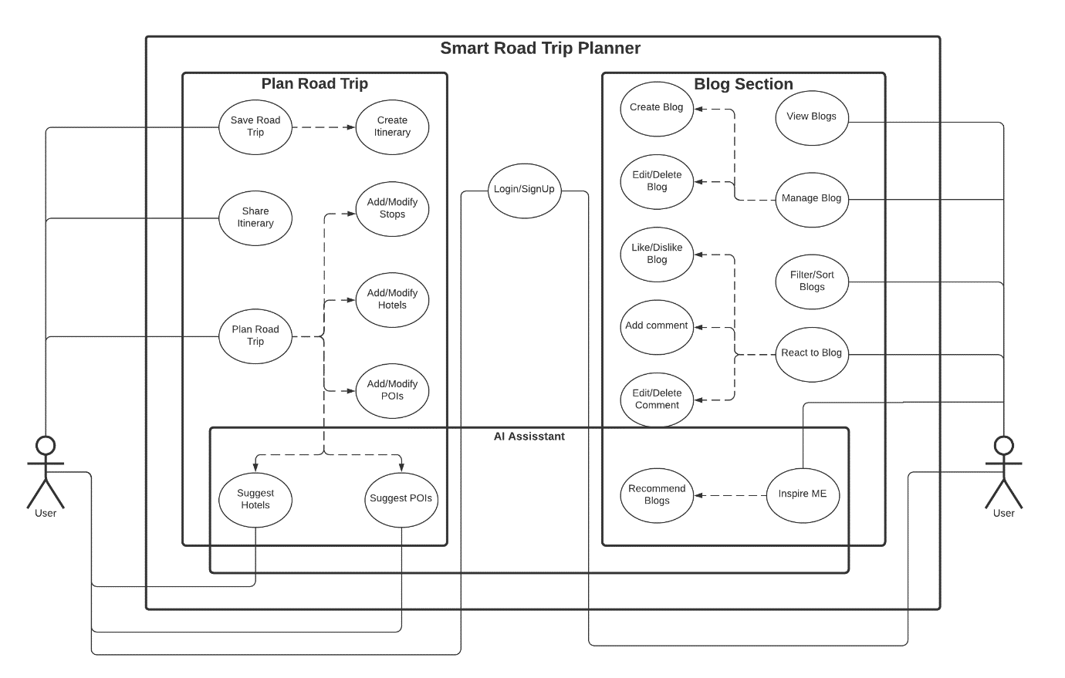

Figure 1 : Use case diagram highlighting the various functionalities of the website. The solid lines represent direct interactions with the user and the dotted lines represent indirect interactions. The AI assistant is built into the backend, capturing every interaction and analyzing the user’s mindset.

In order to enter the trip planning page and start the planning process, the user must first enter the start and destination address in the form provided in the landing page. The trip planning page guides the user through a multi-step process involving three stages– the route, accommodations and places of interest. The route planner, powered by the mapbox API, allows the user to add up to 5 waypoints along the way and dynamically calculates the optimal route between the start and end points.

Once the user has set the waypoints, he can proceed to look for accommodations at each of these locations. This section is backed up by the Hotels.com API, which provides detailed information about a number of hotels. The user can use the sort and filter options to narrow down his search. Hotels can be filtered by themes, amenities, price and star rating and can be sorted by price and rating.

Each item in the list of hotels displayed will feature the hotel’s price per night, its star rating, address and nearby landmarks. The user can click on the View More button if he wishes to see more details. This will trigger a modal pop up that will display all the features of the hotel in detail. This information is organized in four sections: The first section presents an image carousel displaying all the beautiful pictures of the hotel. The second section lists out all the amenities in the hotel whereas the third lists out the special features that the hotel likes to highlight. The last section presents the reviews received by the hotel.

The user can choose to temporarily add the hotel to the itinerary and has the option to remove it later if necessary. Once the accommodations have been set, the user can move on to the last stage of the trip planning process; choosing the places of interest.

This segment is facilitated by the OpenTripMap API which provides basic required information about millions of places around the world. The user can choose from an extensive list of options to filter his search by category. This section is also equipped with a search bar with an auto suggest feature that can help the user to find the desired place of interest. Like the previous stage, the POIs can also be temporarily saved with an option to be removed later.

Once the user has planned all aspects of his road trip, he can click on the Save Itinerary button to confirm his selections. This will generate an itinerary object and redirect the user to a new page where that object will be displayed. This itinerary will contain all the details about the trip, starting from the route with the waypoints, the hotels ordered by the check-in and check-out date, and the places of interest grouped by location and tagged with their categories. This itinerary will also be saved to the user’s profile for future use.

Another major highlight of the website in addition to the trip planning feature is the blog section. To enter this section, the user can click on any of the relevant links either in the navigation bar or in the landing page. Unlike the trip planning page, the user does not have to be logged in to view blog posts. However, he must be logged in if he wishes to add/modify his posts, comments or likes.

The blog section features articles and itineraries posted by the users of the website. The main page of this section contains a list of all blogs that can be filtered by various options. Each blog post contains an account of the user’s experience on the trip and the associated itinerary created on the website. The user can drop a like and/or add a comment in the comments section. Posts and comments created by the user can be modified (edited and deleted).

The entire application will be backed by an AI that will act as a virtual assistant to provide the user with a personalized experience. This AI can support the user in the various stages of the trip planning process. It poses as a recommender that can provide suggestions based on its understanding of the user. In order to be able to do this, the AI captures the interactions (such as button clicks) of the user on the website and uses it to develop its knowledge base.

For hotel recommendations, the AI keeps track of an interest vector of the user. This is a set of key-value pairs where each key represents one feature of the hotel (such as swimming pool, valet parking, price, etc) and the value represents the weight – the inclination of the user toward that particular feature. Using this vector, the AI finds similar users on the website and recommends hotels based on its findings.

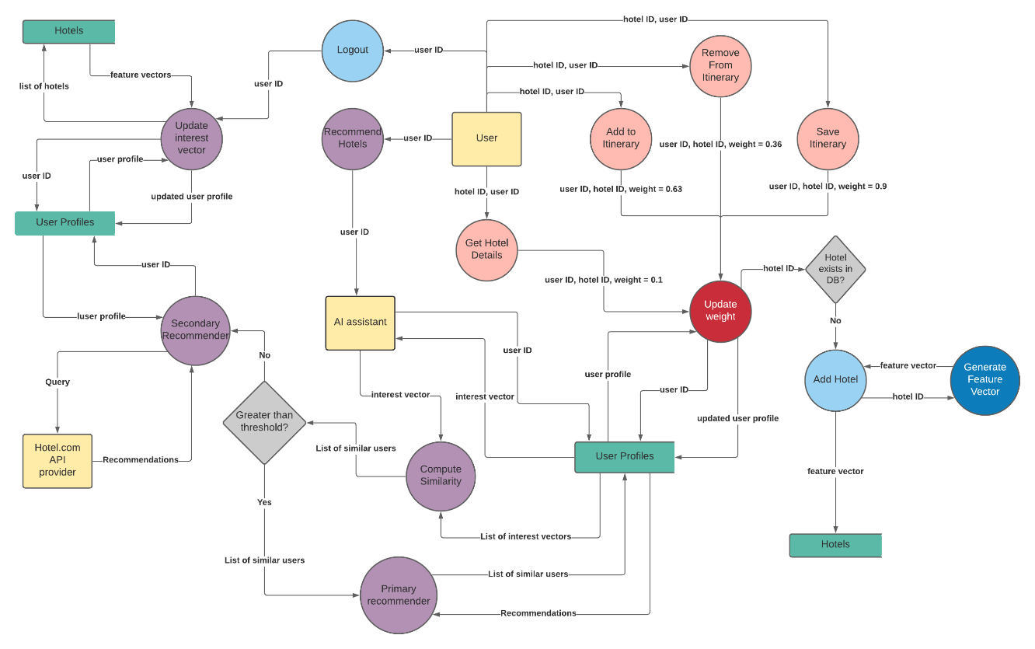

Figure 2 : Data Flow Diagram of the hotel recommendation system. The pink colored processes represent the different types of interactions that are captured by the AI. The green colored data stores represent the knowledge base of the AI and the purple-colored processes represent the various functions performed by the recommender.

For POI recommendations, the AI keeps track of the kinds of places that the user visits. Each place is broken down into categories and each category is assigned a weight. When the user asks for recommendations, it suggests those places that fall under the categories with high positive weights. These weights are also stored by the AI in a POI categories vector.

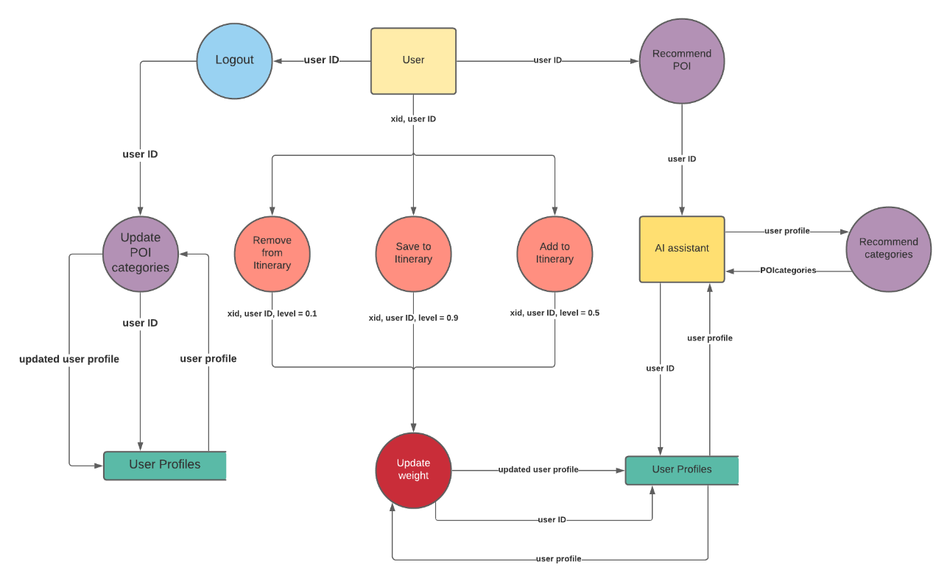

Figure 3 : Data Flow Diagram of the POI recommendation system. The pink colored processes represent the different types of interactions that are captured by the AI. The green colored data stores represent the knowledge base of the AI and the purple-colored processes represent the various functions performed by the recommender.

As for blogs, the AI captures various interactions such as liking the blog, commenting and viewing the itinerary associated with it. For comments, the AI captures the sentiment behind it and stores it in its knowledge base. It uses information such as the cost and duration of the trip mentioned in the blog, along with the number of likes in order to build the user’s blog interest vector. In order to recommend blogs, the AI uses this blog interest in combination with the interest vector and POI categories vector of the user to find our similar user and make relevant recommendations.

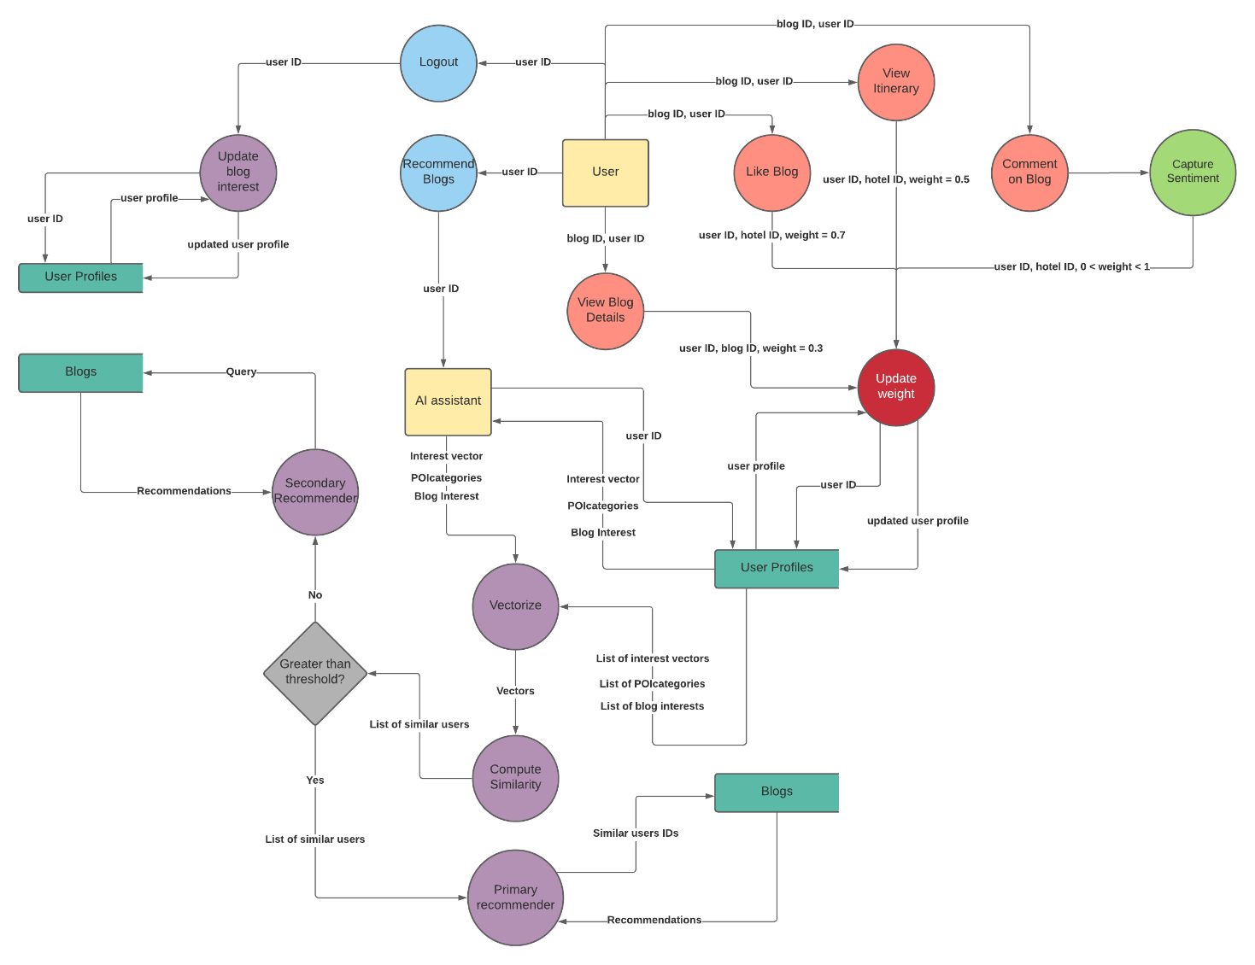

Figure 4 : Data Flow Diagram of the Blog recommendation system. The pink colored processes represent the different types of interactions that are captured by the AI. The green colored data stores represent the knowledge base of the AI and the purple-colored processes represent the various functions performed by the recommender. It can be seen that the blog recommender is an extension of the hotel recommender as it accounts for the user’s hotel interests as well as sightseeing interests while generating recommendations.

One thing to note is that all the weights assigned to the attributes used by the AI are time sensitive, i.e., more recent interactions are given more priority over older interactions. This way, the AI can also keep track of the changing interests of the user with time and adapt to it appropriately.

**AI Recommender Model**

The AI recommender is broken down into three models, each one assisting a different functionality on the website. These three models are: Hotel recommender, POI (places of interest) recommender and Blog recommender. These models are built on top of the knowledge base gathered by the AI through the various interactions on the website

*The Knowledge Base – User Profile*

The knowledge base of the AI is represented as a “user profile” in the database of the website. Every user on the website has an associated user profile. This profile contains all the information that the AI has gathered about the user. This user profile is made up of six attributes. *Hotels*, *POI* and *Blogs* store the all the interactions made by the user. *Interest Vector*, *POI Categories* and *Blog Interest* represent what the AI knows about the user based on these interactions and is updated every time after the user logs out of the website. These attributes are used by the AI to make recommendations.

*The Hotel Recommender*

Four different types of hotel interactions are captured by the AI:

* When the user clicks on a hotel to view more details, that interaction is captured with a weight of 0.1
* When the user adds a hotel to an itinerary, that interaction is captured with a weight of 0.63
* However, if the user removes a hotel from an itinerary, that interaction is captured with a weight of 0.36
* Finally, when the user decides to save an itinerary, all hotels part of the itinerary will be updated to a weight of 0.9

These captures are performed by the *Update Weight* function. Since the website relies on API hotel data, the AI does not have a hotel database to use. Therefore, every hotel interaction on the website is followed by breaking down that hotel into its basic attributes (known as a feature vector), and storing the feature vector to build a hotel database. The AI then uses this hotel database to power its primary hotel recommender.

These recommender models are made up of two smaller models: A Primary recommender and a Secondary recommender. The reason for this is that the Primary recommender relies entirely on the users’ interaction on the website; the more the number of users and more the number of interactions, the better the recommendations. This can lead to a cold start problem when the website is first launched due to insufficiency of users. This is where the Secondary recommender comes in. The Secondary recommender acts as a backup when there are insufficient users or when the similarity between users isn’t good enough. This recommender only takes into account the given user’s interest and uses just that to make recommendations.

Therefore, when the user asks for recommendations, the AI gets the interest vector of that user and the interest vectors of all other users on the website. If the number of users is insufficient, the AI resorts to the Secondary recommender. Otherwise, it calculates the cosine similarity between the given user and the other users based on the interest vectors. It then gets the top 5 most similar users and passes this information on to the Primary recommender. However, if the similarity between the users doesn’t cross a certain threshold, the AI again resorts to the Secondary recommender.

When a user logs out, the interactions made by that user during that session have to be accounted for. This is the purpose of the *Update Interest Vector* function. It first locates the user profile of the user and extracts the hotels that have not been accounted for. It then proceeds to update the various attributes of the interest vector, starting with the facility filters and the theme filters.

The stars, price, and guest review attributes are all features that represent a weighted average of the user’s interest with the weight being a combination of timestamp and the captured weight. These are thus updated by calling a *weighted average* function that updates the average value.

On the other hand, attributes such as themes and facilities are features that represent a weighted count of the user’s interest (with the weight being the same as before). The reason it’s a weighted count and not a weighted average is because the amenities and themes are a string of 1s and 0s and thus cannot be added but rather have to be counted. Hence these are updated by calling a *weighted count* function that updated the count value.

By considering the timestamp as part of the weight, the model captures the user’s changing interest with time and makes sure the recommendations are in line with the user’s current interests.

*The POI Recommender*

Unlike the hotel recommendation system (or the blog recommendation system), the POI recommender is fairly simple mainly due to the amount of information it has to capture and analyze from every POI. In this case, three different types of POI interactions are captured by the AI:

* When the user saves a POI to the itinerary, that interaction is captured with a weight of 0.5
* If the user removes a POI from an itinerary, that interaction is captured with a weight of 0.1
* Finally, when the user decides to save an itinerary, all POIs part of the itinerary will be updated to a weight of 0.9

These captures are again performed by an *Update Weight* function. This function works very similar to that of the hotel recommender model with a few exclusions.

This recommender model, unlike the other two, is not made up of a Primary and Secondary component. The reason is because the recommendations are only based on one feature (the categories) and thus does not necessitate the usage of the similar user’s approach. Instead, the user’s POI history alone is sufficient to generate relevant recommendations.

The recommender first locates the user profile of the given user and extracts the list of POI interactions. It combines the weight of these interactions along with the timestamp to get a time-based weight. It then compiles a list of all the categories that all the POI interactions are a part of and assigns the respective time-based weight to each of these categories. It finally returns those categories with the highest weight as the recommendations.

By considering the timestamp as part of the weight, the model captures the user’s changing interest with time and makes sure the recommendations are in line with the user’s current interests.

*POI mapping system:* The different POI categories (over a 100 categories) are stored as a tree structure where every child is a subcategory of its parent (for example, “beaches” are a subcategory of the “natural” category). The mapping system follows three rules:

* The scale of the number of a node (number of digits to the right of a decimal point) is equal to the level of the node (for example, nodes at level 2 of the tree will have 2 digits to the right of the decimal point).
* Child nodes inherit values from the parent nodes.
* Nodes at one level are numbered starting from the left extreme of the level.

Using these rules, say “natural” is a child node of “interesting places” (value 3) and is the fourth node on its level (level one). Its value will therefore be 3.4. Similarly, if “beaches” was the first child node of “natural”, then its value would be 3.41.

Although not used to make recommendations, the *POI Categories* attribute of the user profile stores the top 3 most preferred categories of the user and this function is used to update that list every time after the user logs out. These categories are stored as numeric values (for reasons that will be explained in the blog recommender). These numeric values are obtained through the unique mapping system that ensures that similar categories have similar values.

The reason this attribute is not used to make recommendations is because the approach mentioned in the recommender can make sure that the interactions of the user in the current session are also accounted for (which is harder in the case of blogs and hotels due to the sheer number of attributes).

*The Blog Recommender*

The blog recommender is an extension of the hotel recommender model. Four different types of blog interactions are captured by the AI:

* When the user opens a blog to read the article, that interaction is captured with a weight of 0.3
* When the user opens the tab to view the itinerary associated with the blog article, that interaction is captured with a weight of 0.5
* If the user likes a blog, that interaction is captured with a weight of 0.7
* The AI can also capture the sentiment behind the comments made by the user on the blog. This sentiment is assigned to be the weight of the comment interaction and can vary from 0 to 1 depending on the nature of the comment.

*Sentiment Analysis:* As mentioned above, the AI can also capture the sentiment behind every comment made by the user on the blogs and use this to better understand the user mindset. This is done with the help of a machine learning sentiment analyser model that has been hosted on the cloud. This model takes in a comment as an input and returns a value between 0 and 1 depending on the type of comment; positive comments will return a value close to 1 and negative comments will return a value close to 0.

The blog recommender is also made up of a Primary and Secondary recommender (for reasons already mentioned in the hotel recommender model). When the user clicks on the recommend blogs button, the AI locates the user’s user profile and the user profile of all other users. It then extracts three attributes from these user profiles: the *interest vector*, which represents the user’s hotel interests, the *POI categories*, which represents the user’s most preferred sightseeing places, and the *blog interest*, which is representative of the kind of blogs that the user has frequently interacted with. It then passes these three attributes to the *vectorize* function that groups these features together and returns a vector that represents the AI’s complete understanding of the user.

The rest of the procedure is similar to the hotel recommender model. The AI compares the cosine similarity between these vectors and if the similarity does not cross a certain threshold, or if the number of users for comparison are insufficient, the AI resorts to the Secondary recommender. Otherwise, it uses the Primary recommender.

When a user logs out, the blog interactions made by that user during that session must also be accounted for. This is performed by the Update Blog Interest function. This is done by first locating the user profile of the user and extracting the blogs that have not been accounted for. This is then followed by updating the various attributes of the *blog interest vector* which includes cost, duration and likes. These are features that represent a weighted average of the user’s interest with the weight being a combination of timestamp and the captured weight. These are thus updated by calling a *weighted average* function that updates the average value.

By considering the timestamp as part of the weight, the model captures the user’s changing interest with time and makes sure the recommendations are in line with the user’s current interests.

**Screenshots**

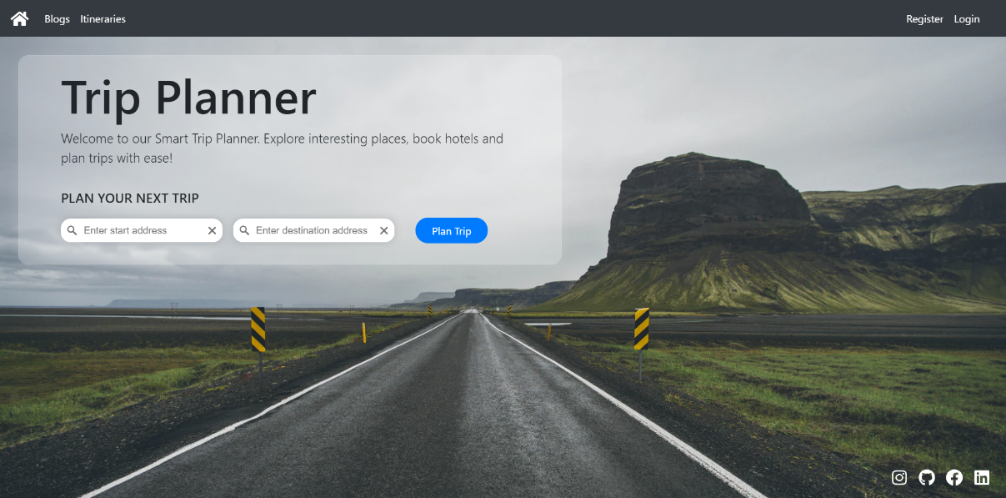

Figure 5 : Landing page. This is the first page that the user will see when he/she accesses the website. The navigation bar on top provides quick links to the different pages of the website and the form on the home page can help the user get started on his/her trip planning process.

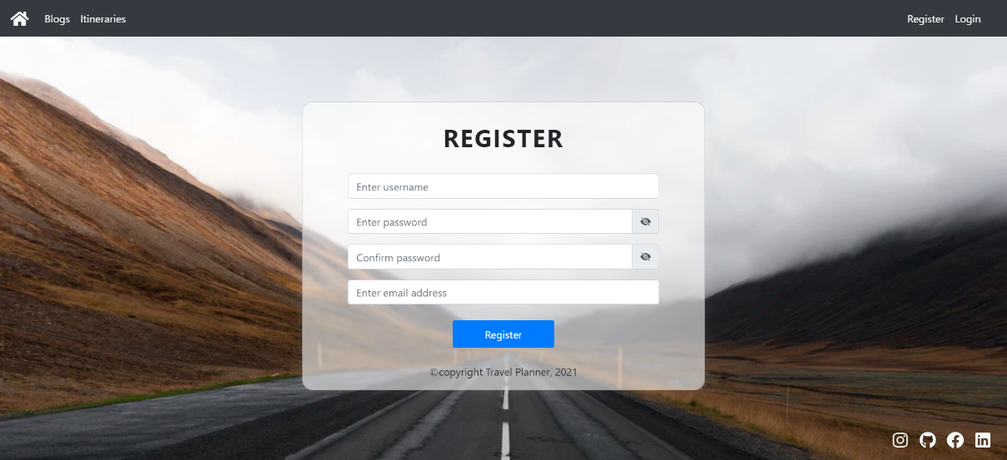

Figure 6 : Register page. Users need to have an account in order to make use of the trip planning features of the website. The register page can be used by the user to create a new account. It requires minimal information such as the username, password and the user’s email.

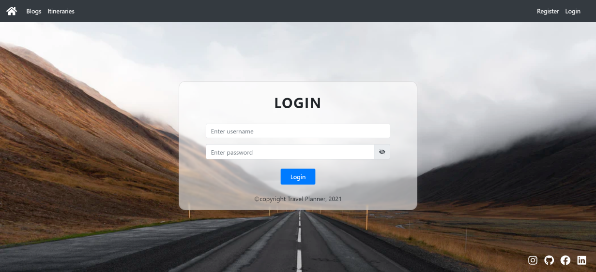

Figure 7 : Login page. In case the user has an existing account, he/she can use the login page in order to login to the website. It takes in the username and password and creates a JSON web token that is used to give the user access to the website.

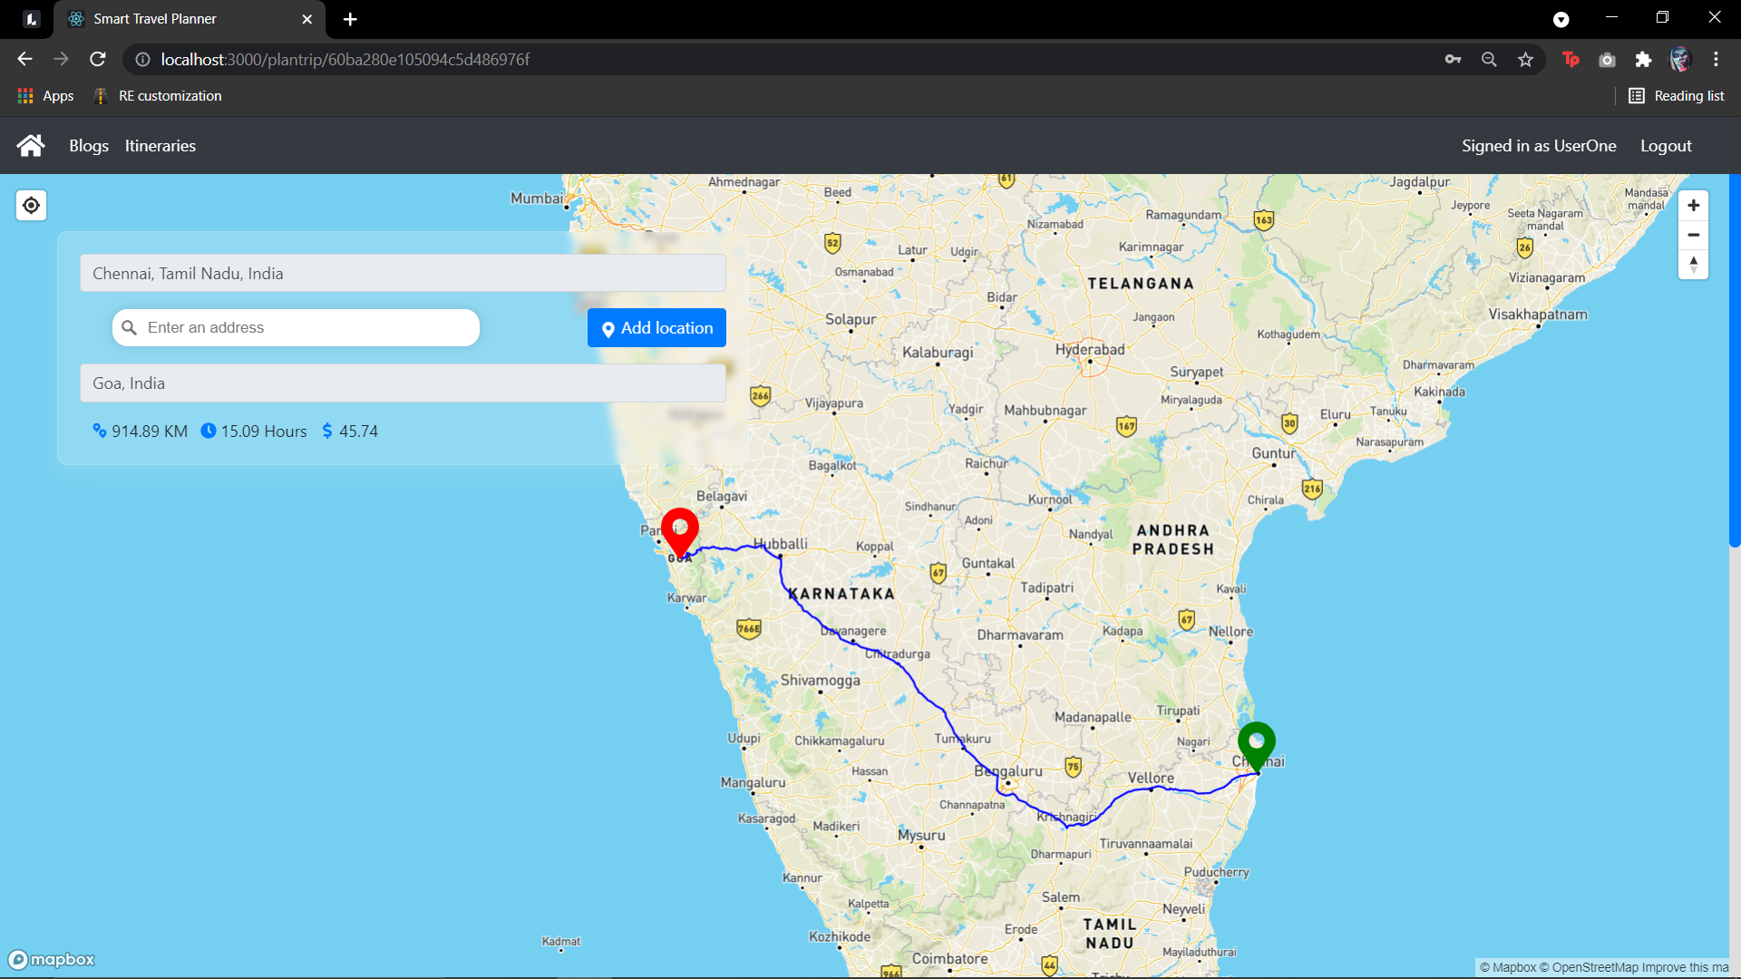

Figure 8 : Route planner. Once the user enters the start and destination addresses in the homepage, he/she will be redirected to the page shown above. Our route calculator will display the optimal route and the corresponding distance, travel time and estimated fuel price. This map functionality is powered by the MapBox API

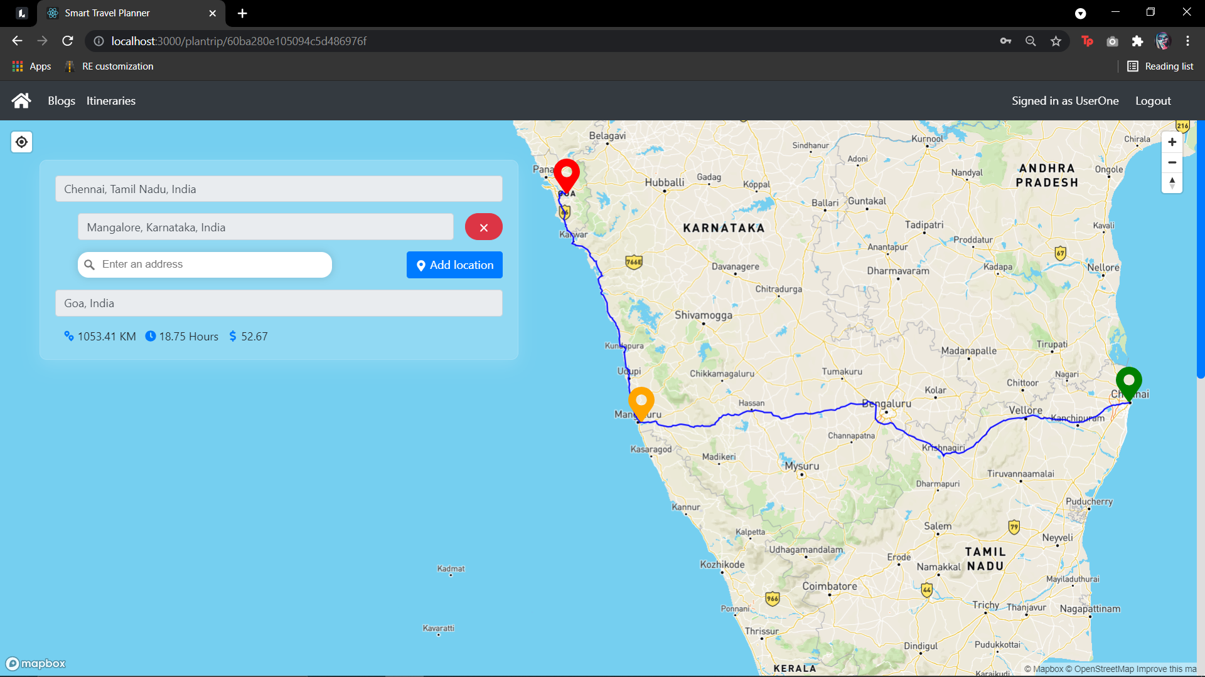

Figure 9 : Route planner (cont.). Users can also add waypoints to their route (intermediate stopping points). Our route calculator is designed to optimize the route and display the estimated distance, travel time and estimated fuel price. Using this, the user can carry out the route planning aspect of the trip planning process.

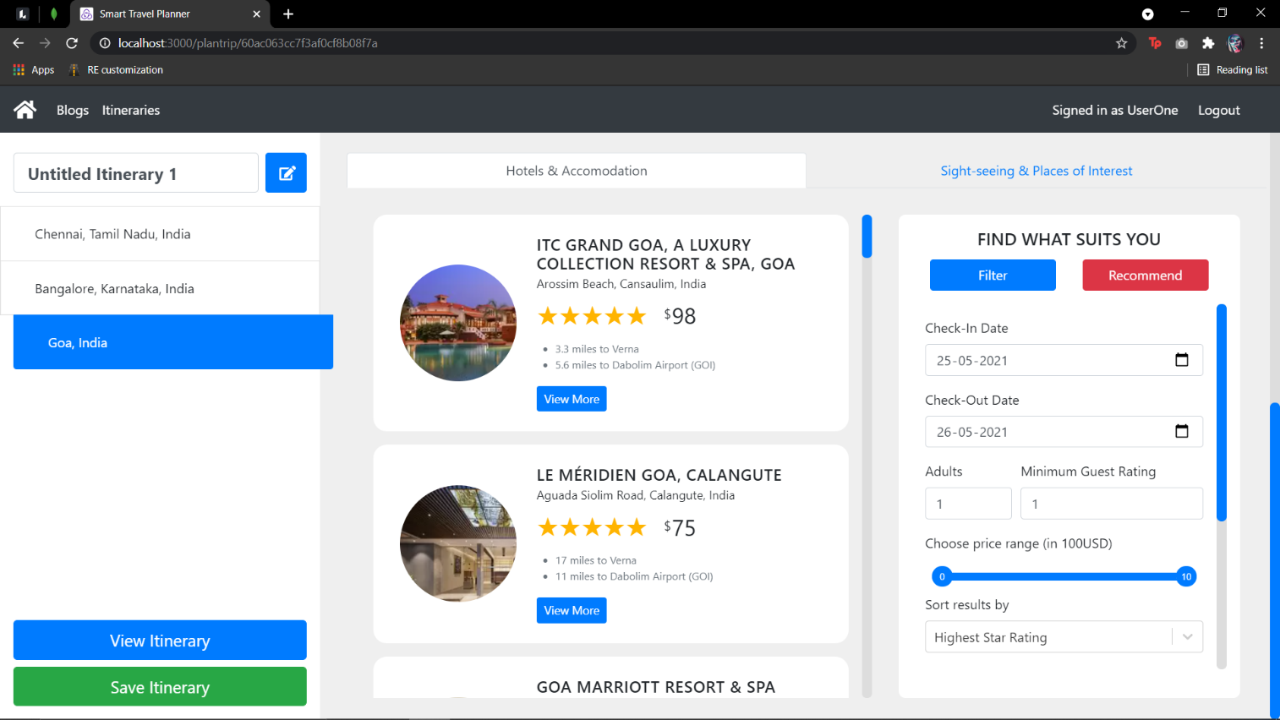

Figure 10 : Hotel overview and the sort features. Once the user is satisfied with the route of the trip, he/she can then move on to exploring different accommodations at each of the waypoints. Each hotel item displays brief information about the hotel such as the star rating, the price per night per room and the distance to various landmarks. On the right is the sort and filter tab that the user can use to narrow down the search. Hotels can be sorted by price, star rating and guest rating.

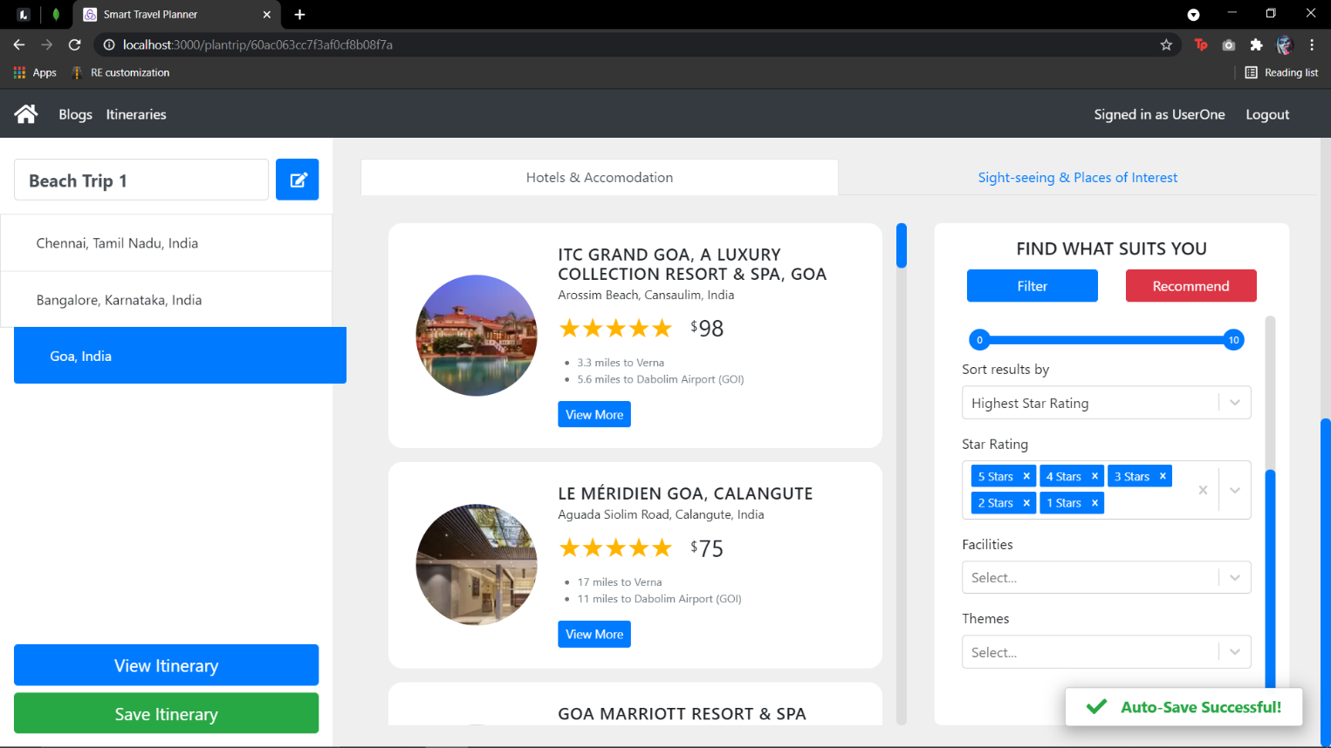

Figure 11 : Hotel overview and the filter features. Hotels can also be filtered by price and star rating. In addition to this, hotels can also be selected based on the themes and the facilities (amenities) that they offer. The auto-save feature makes sure that the user does not lose any unsaved progress and is triggered 15 seconds after any change is made to the itinerary.

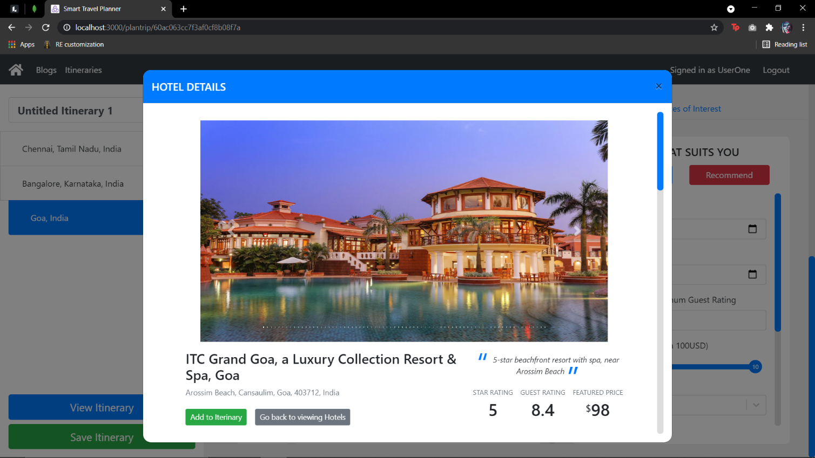

Figure 12 : Hotel details (picture slideshow). Users can also choose to view more details about any hotel. In the above image, we can see a slideshow of the hotel photos along with the address, star rating, guest rating and price per night at the hotel.

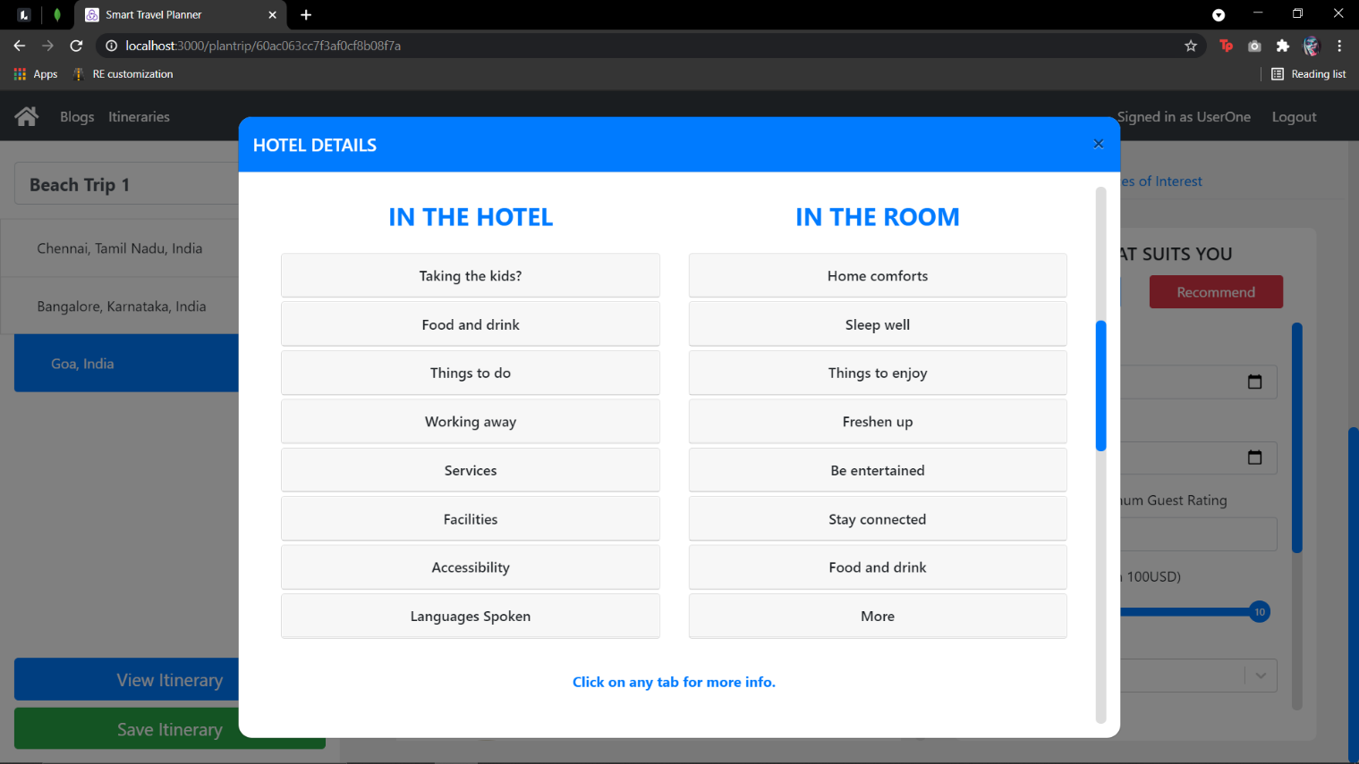

Figure 13 : Hotel details (amenities). As we scroll down, we will be able to see the various amenities that the hotel has to offer. Each of the tabs can be clicked on to view more info about that particular amenity.

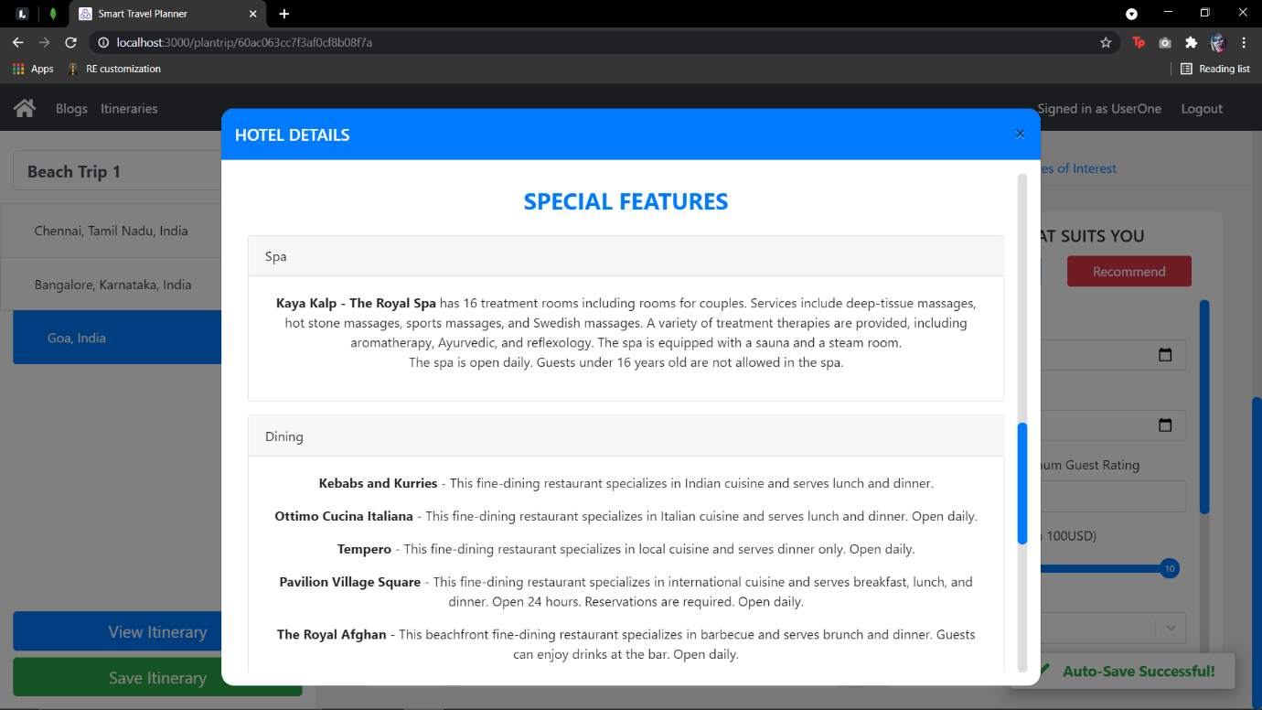

Figure 14 : Hotel details (special features). Moving further down, the user can view the various highlighting features of the hotel. This can vary from hotel to hotel and is used to display the unique features of the hotel in the spotlight.

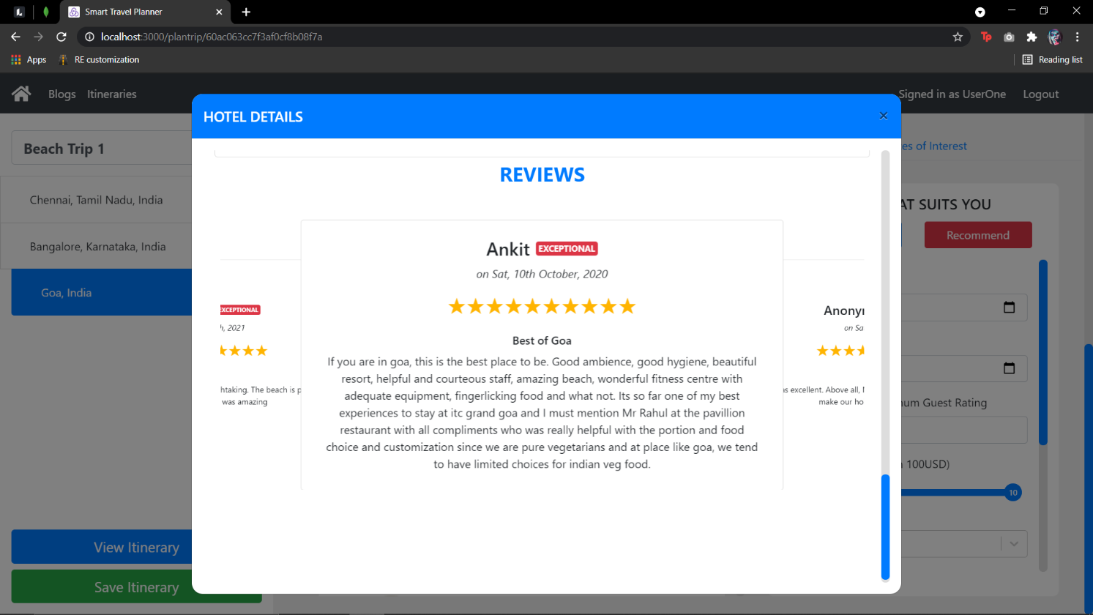

Figure 15 : Hotel details (reviews). At the end of the modal, the user can view the various reviews given by users who have stayed at the hotel. Each review consists of the name of the person who posted the review, the timestamp, the guest rating out of 10, and the review itself.

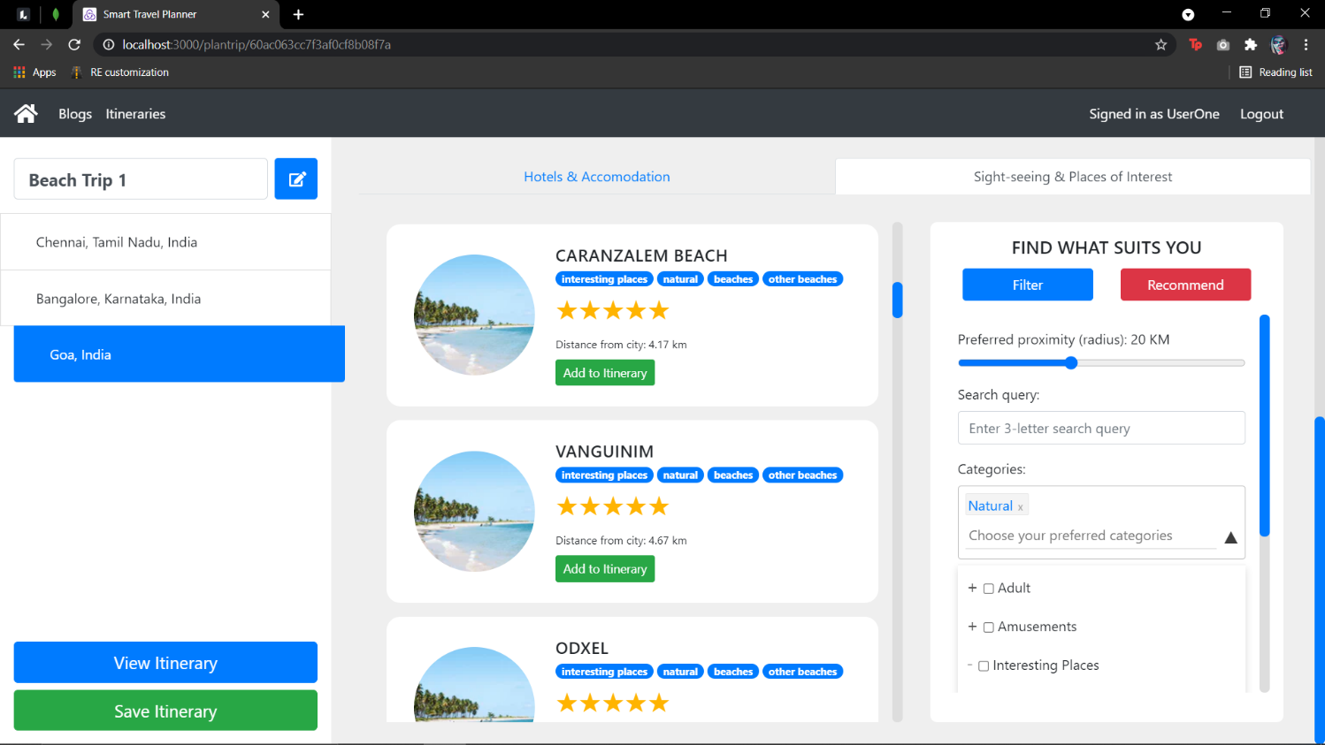

Figure 16 : POI overview with filters. Once the user has finished selecting hotels for the trip, he/she can move on to exploring the various sightseeing places. Our website offers a plethora of POIs that can be filtered using our tree-structured category filter. Using this, along with the query search option, the user can quickly narrow down his search for POIs.

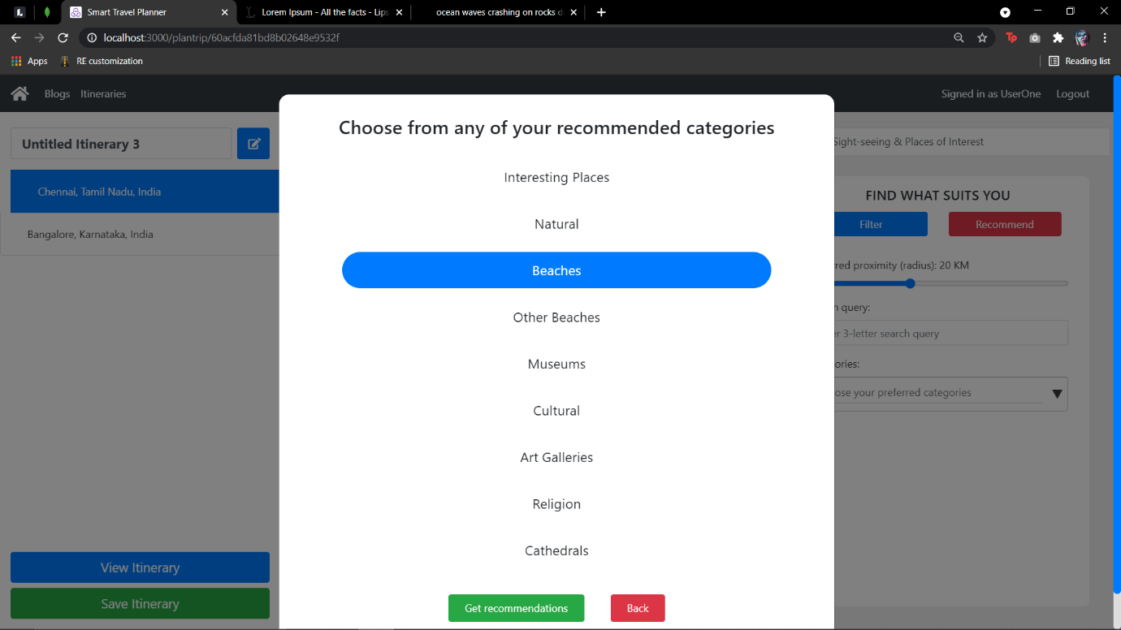Figure 17 : POI recommendations. Every POI interaction made by the user is captured by the AI and is broken down into its fundamental categories and stored in the knowledge base. Using this knowledge, the AI can generate category recommendations for the user based on his previous interests.

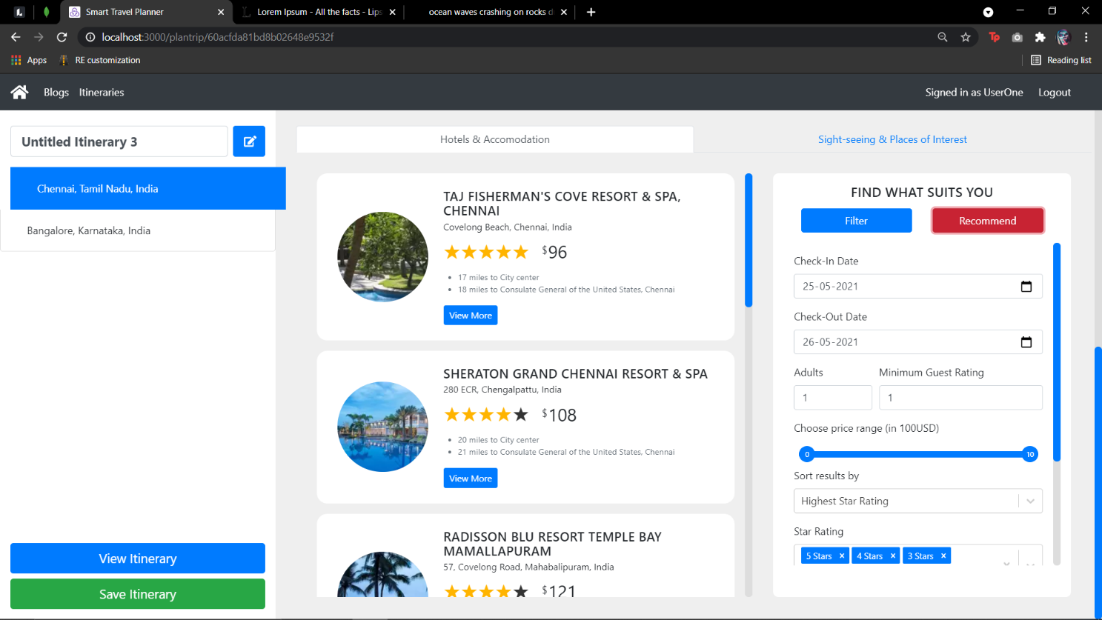

Figure 18 : hotel recommendations. Every hotel interaction made by the user is broken down into its basic features and stored in the knowledge base. These features include the various attributes such as price, amenities, etc. The AI uses this knowledge to find out users similar to the given user and use that to generate recommendations.

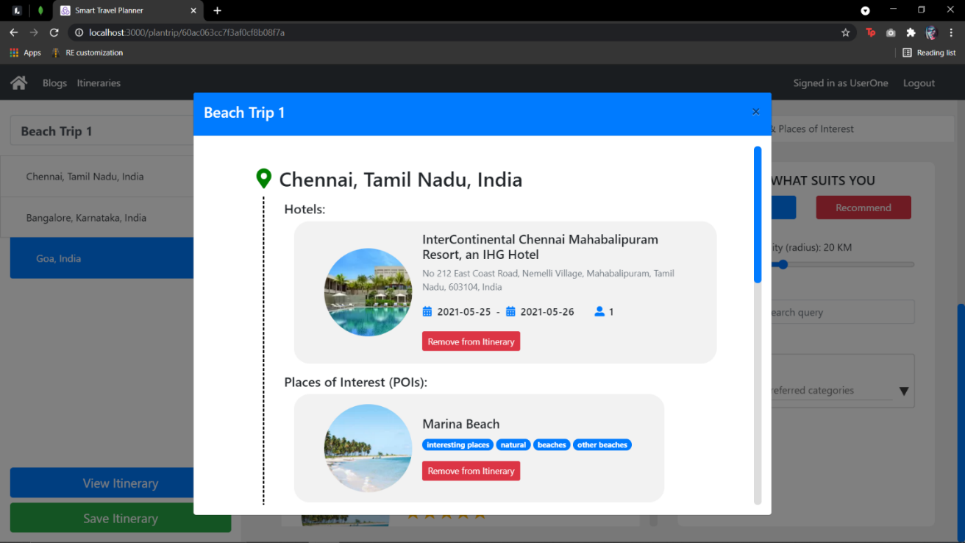

Figure 19 : Itinerary preview. At any given moment during the trip planning process, the user can preview the itinerary he/she has created so far and make changes if necessary.

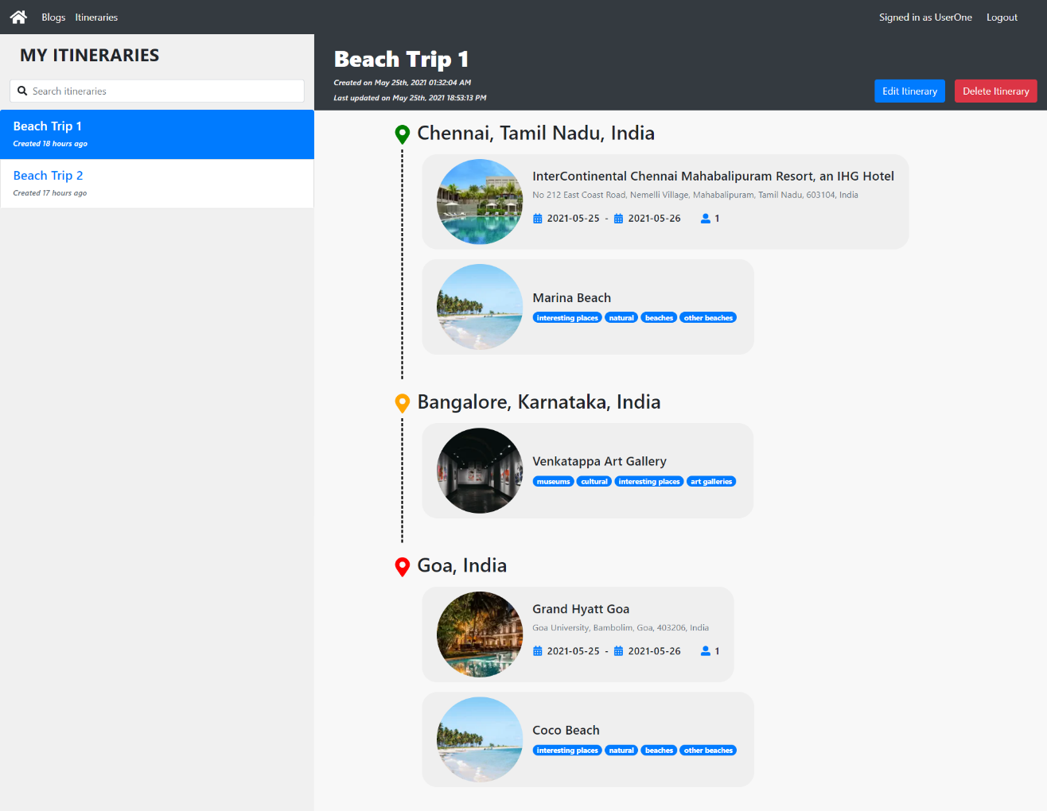

Figure 20 : Itineraries page. Once the user has finished creating and saving the itinerary, he/she will be redirected to the itineraries page where he/she can view a list of all itineraries created so far. Each itinerary will contain basic information such as the list of hotels along with the POIs at each stopping point along the route. These itineraries can also be edited in the future if necessary.

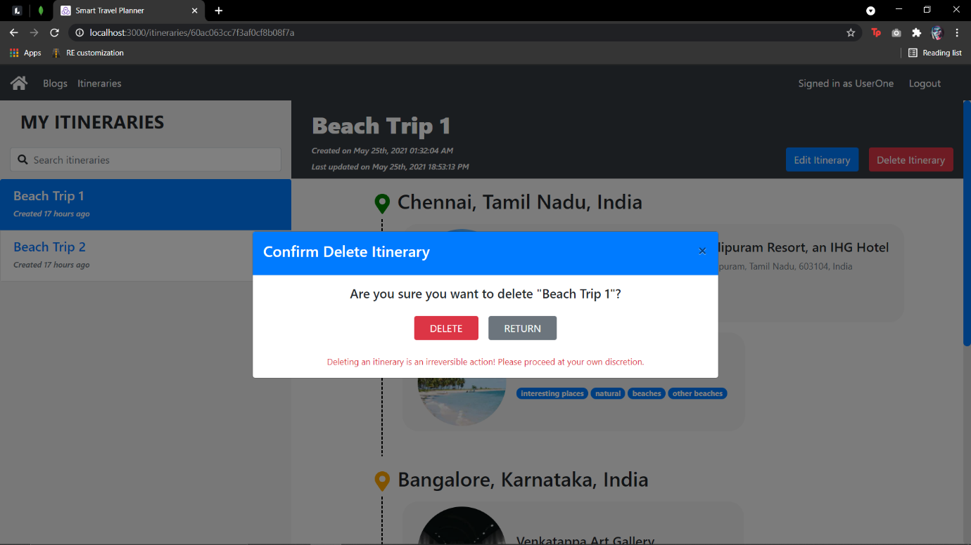

Figure 21 : Delete itinerary modal. If the user wishes to delete an itinerary, he/she can do so by clicking on the delete itinerary button. This will trigger a confirmation modal following which the itinerary will be remove from the database.

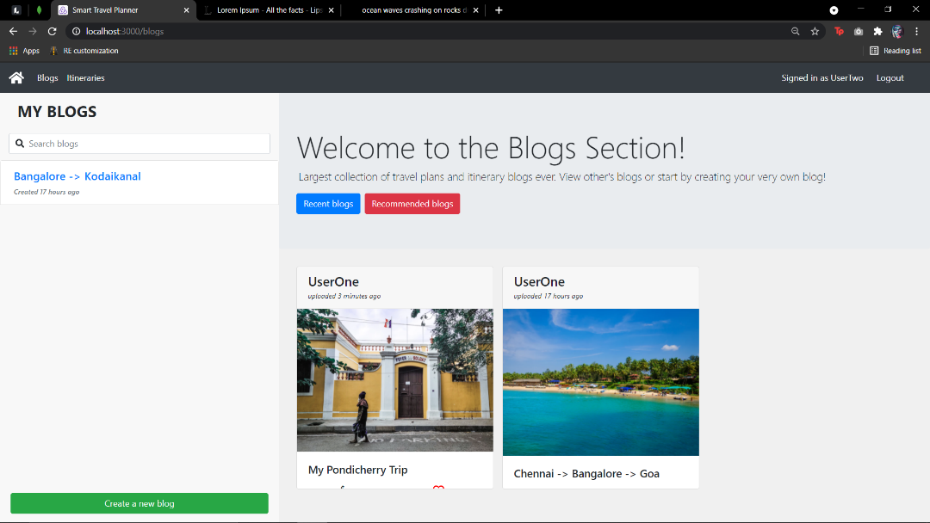

Figure 22 : Blog section overview. For users looking for inspiration to travel, we have a blog section featuring the various travel blogs posted by other users who wanted to share their trip experience. The Blog homepage shows the list of blogs which on hover will show the number of likes, comments, price and trip duration. On the left, a list of blogs created by the user is also available.

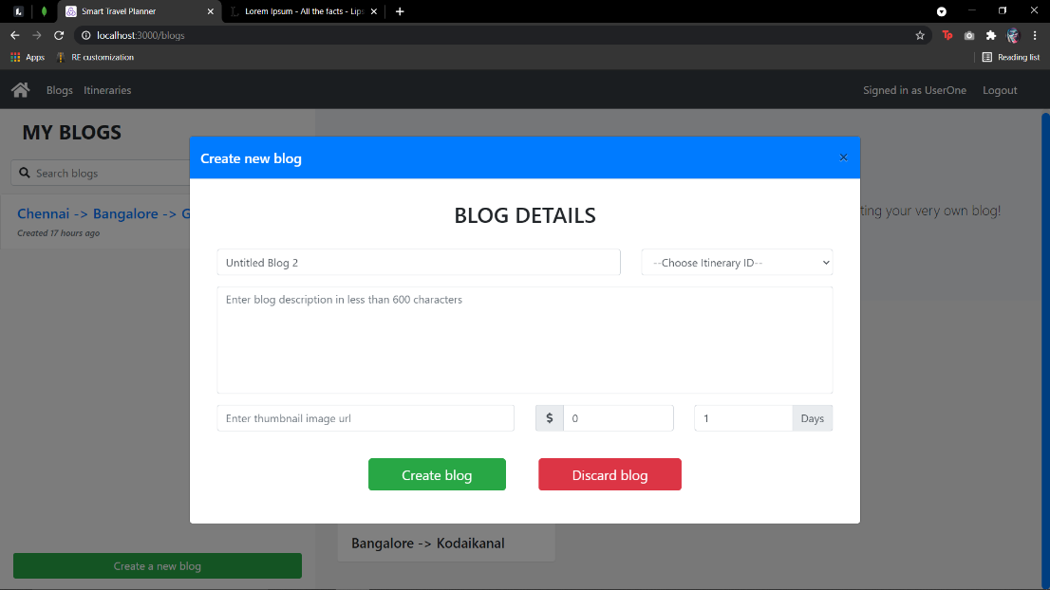

Figure 23 : Blog create (add header). Blog creation is a two-step process. In the first step, the user has to add the blog name, link an itinerary, add the blog description, thumbnail image, price and trip duration. Following this, he/she will be redirected to add the blog content.

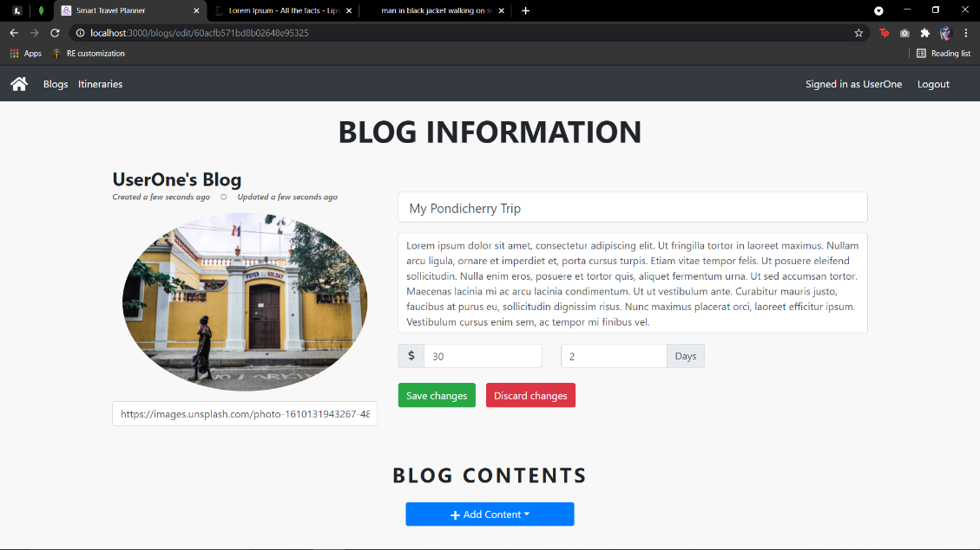

Figure 24 : Blog create (add body). In the second step, the user will be prompted to add blog content. This can be of two types: image or text. This content can also be reordered by the user and since the entire blog creation is designed to be flexible, the user can edit any part of the blog as and when required.

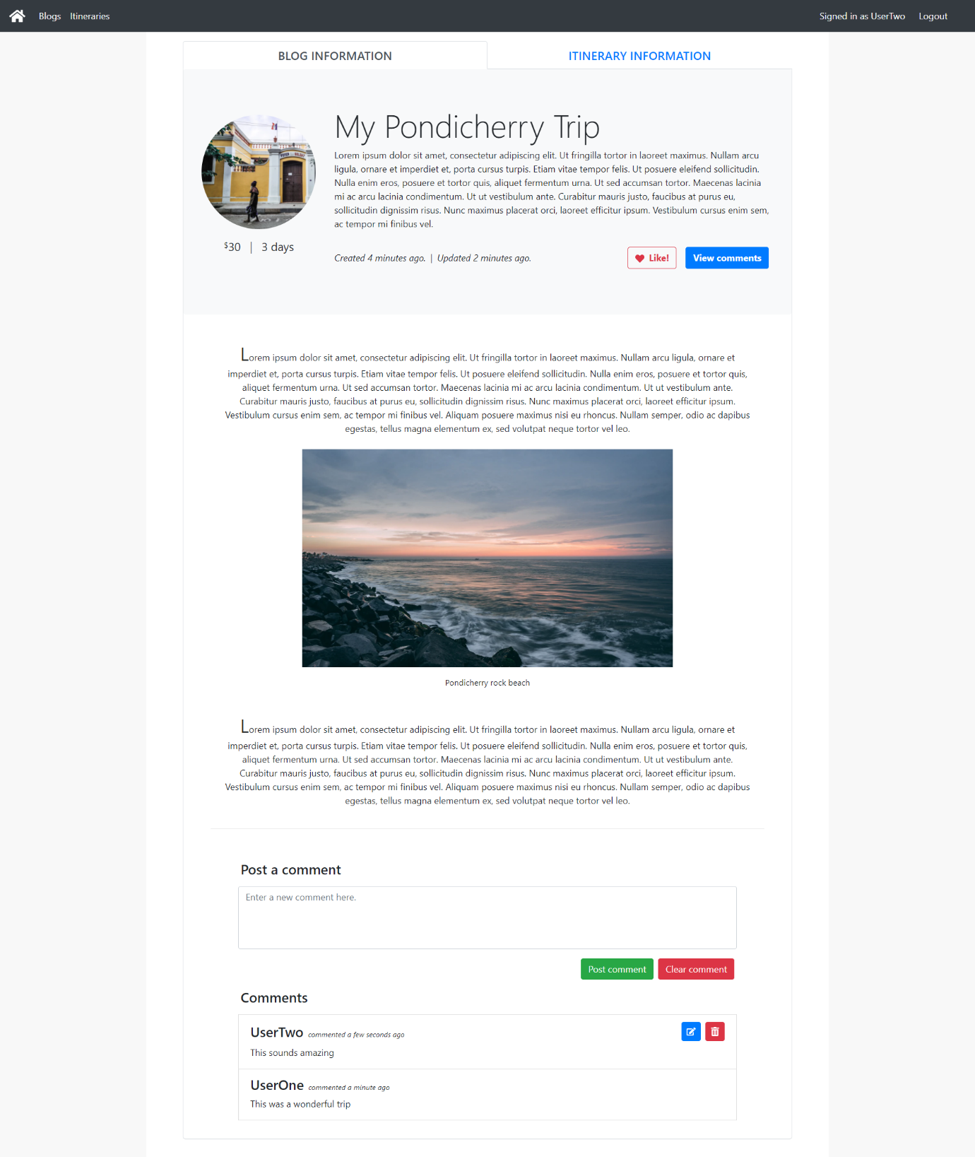

Figure 25 : Blog view page with comment section (article). This image is a sample of what a blog looks like. It contains a header which includes information such as a brief description, duration and price along with a like and comment button. This is followed by the body of the blog which is a combination of text and image content. Blogs are also equipped with a comment section where users can share their opinions of the blog.

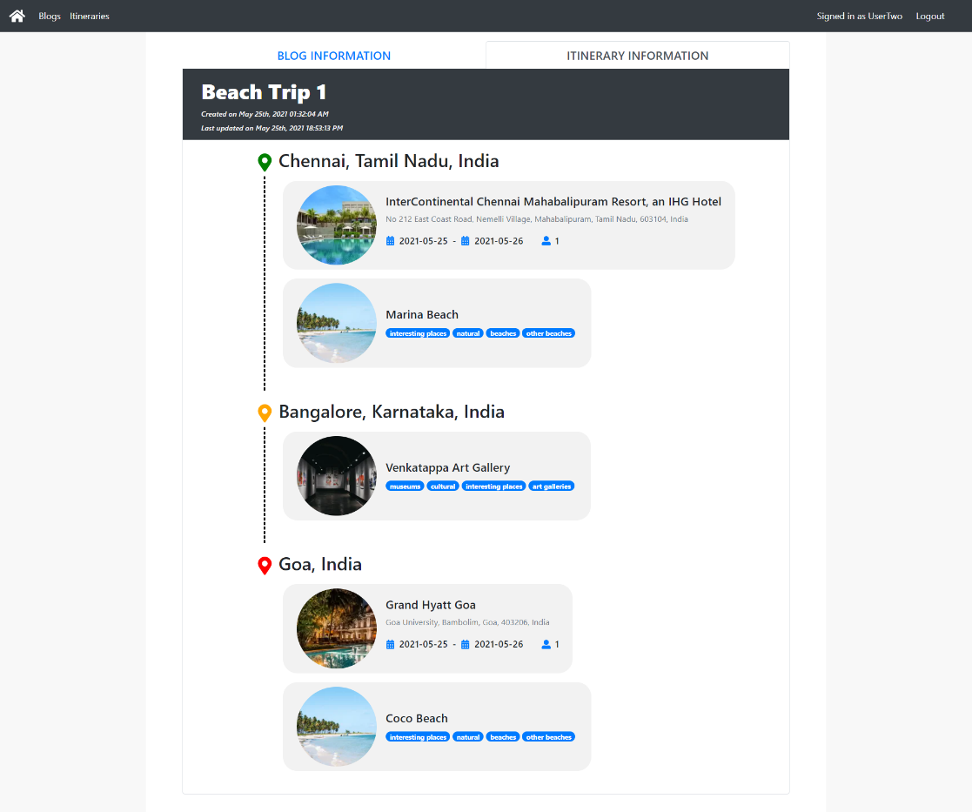

Figure 26 : Blog view page (associated itinerary). Every blog has an associated itinerary page. Users who are interested in the blog content can switch to this page to view the associated itinerary that can be saved and used later.

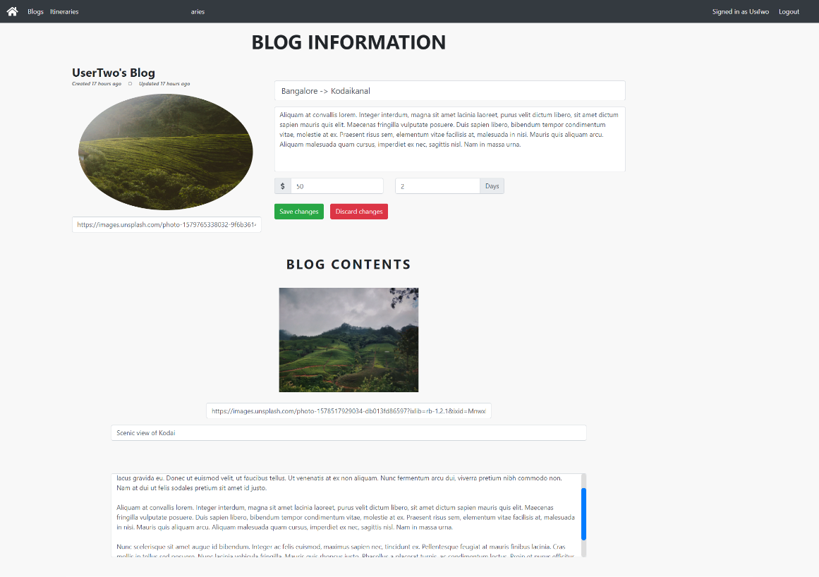

Figure 27 : Blog edit page. As mentioned before, the blog design offers its users flexibility. Users can edit any part of the blog whenever required.

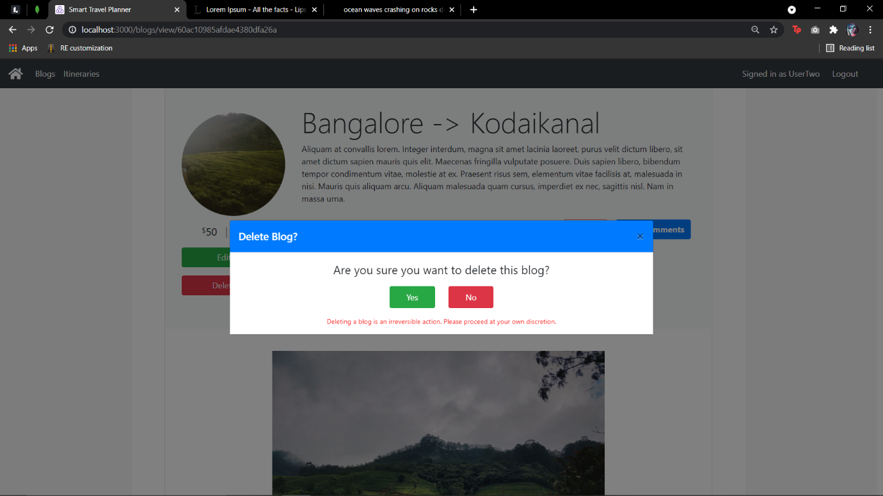

Figure 28 : Blog delete page. Users can also choose to delete a blog. This will trigger a confirmation modal following which the blog will be removed from the database.

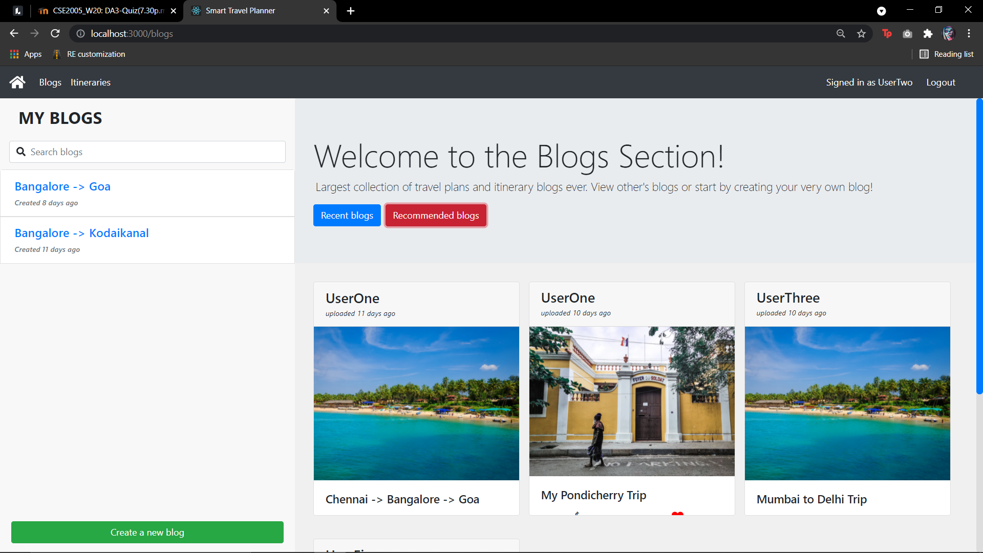

Figure 29 : Blog recommendations. The AI even captures the interactions made on the blog page. Everything from opening the blog to commenting on it is captured and analyzed by the AI. The above image is a sample recommendation output for a user who has a history of going on beach themed trips. It can be seen that the top 2 recommendations for this user are in line with his interests, as they are also beach themed trips.

**Conclusion**

In this project, we developed a system that could act as one-stop solution for users who were looking to plan their next trip by assisting them in a step-by-step manner. Powering the system with APIs allowed us to gather a rich collection of data to display to our users. We managed to integrate all the essential aspects of trip planning into one piece of software. Various functions, starting from route planning and optimizing, to exploring hotels for accommodation and other places of interest for sightseeing, were all wrapped up and delivered as a web application. We also managed to personalize the user’s experience by building an AI that captured and analyzed all user interactions. By doing so, we were able to understand the user’s mindset and generate recommendations that were in line with the user’s interest. In addition to this, we also added a blog section where users could not only share their road trip experience, but also derive inspiration for their next trip.

**Future Scope**

We believe there is a lot of potential to develop the AI model of the website. We plan to refine the weighting system by taking more aspects into consideration such as the number of times a particular hotel or POI is revisited. As of now, the interactions captured in the blog section are only partially reflected back in the trip planning section. We intend to improve this by mutually updating the knowledge base of the AI using both the sections simultaneously. We also plan to extend the model by enabling it to generate starter templates, recommend destinations, provide personalized checklists and build a chatbot UI for more convenient access. As for the rest of website, we’re aiming to bring in more data from new APIs to provide more information such as the details of various POIs (which includes working hours, photos, review, etc.). We would also like to have more user-user interaction on the website so we plan to incorporate a messaging functionality that users can use to connect with other users of similar interests.

**References**

[1] Souffriau, Wouter & Vansteenwegen, Pieter. (2010). Tourist Trip Planning Functionalities: State–of–the–Art and Future. 474-485. 10.1007/978-3-642-16985-4_46.

[2] Soo, V. W., & Liang, S.-H. (2001). Recommending a trip plan by negotiation with a software travel agent. In Co-operative Information Agents V, LNCS 2182 (pp. 32- 37). Berlin/Heidelberg, Germany: Springer

[3] Ardissono, L., Petrone, G., Segnan, M., & Torasso, P.(2002). Ubiquitous user assistance in a tourist information server. In Proceedings of the 2nd international conference on adaptive hypermedia and adaptive web-based systems, LNCS 2347 (pp. 14–23).

[4] Suna, Y., & Lee, L. (2004). Agent-based personalized tourist route advice system. In ISPRS Congress Istanbul 2004, Proceedings of Commission II (pp. 319–324).

[5] Maruyama, A., Shibata, N., Murata, Y., Yasumoto, K., & Ito, M,. (2004a).P-tour: A personal navigation system for tourism. In Proceedings of 11th World Congress on ITS (pp. 18-21)

[6] Hagen, K., Kramer, R., Hermkes, M., Schumann, B & Mueller, P. (2005). Semantic matching and heuristic search for a dynamic tour guide. In Information and communication technologies in tourism. Berlin: Springer.

[7] Lee, C.-S., Chang, Y.-C., & Wang. M.-H. (2009). Ontological recommendation multi-agent for Tainan city travel.Expert Systems with Applications, 36, 6740–6753.

[8] Niaraki, A. S., & Kim, K. (2009). Ontology based personalized route planning system using a multi-criteria decision-making approach. Expert Systems with Applications, 36, 2250–2259.

[9] R. Jafri, A. S. Alkhunji, G. K. Alhader, H. R. Alrabeiah, N. A. Alhammad and S. K. Alzahrani, "Smart Travel Planner: A mashup of travel-related web services," 2013 International Conference on Current Trends in Information Technology (CTIT), Dubai, United Arab Emirates, 2013, pp. 181-185, doi: 10.1109/CTIT.2013.6749499.

[10] Sylejmani, Kadri & Dika, Agni. (2011). A SURVEY ON TOURIST TRIP PLANNING SYSTEMS. International Journal of Arts & Sciences, Gottenheim, Germany. ISSN: 1944-6934. pp 13 - 26.

[11] Choi, Soojin & Jang, Soocheong & Morrison, Alastair M. (2012). Structure of Travel Planning Processes and Information Use Patterns. Journal of Travel Research. 51. 26-40. 10.1177/0047287510394191.

[12] Pan, Bing & Muller, Brian. (2007). Developing Web-Based Tourist Information Tools Using Google Map. 503-512. 10.1007/978-3-211-69566-1_46.

[13] Lim, Kwan Hui & Chan, Jeffrey & Karunasekera, Shanika & Leckie, Christopher. (2019). Tour recommendation and trip planning using location-based social media: a survey. Knowledge and Information Systems. 60. 10.1007/s10115-018-1297-4.

[14] Soufriau, W. and Vansteenwegen, P. (2010) Tourist Trip Planning Functionalities: State-of-the- Art and Future, Proceedings from International Workshop on Web Engineering & Tourism, Vienna, Austria.

[15] Grün, C., Pröll, B., Retschitzegger, W., Schwinger, W., Werthner, H. (2008). Assisting Tourists on the Move - An Evaluation of Mobile Tourist Guides. Submitted for the 7th International Conference on Mobile Business. Barcelona, Spain

[16] Beraldi, P., De Maio, A., Olivito, F., Potrino, G., Straface, I., & Violi, A. (2021). a decision support system for trip tourism recommendation. *International Journal of Transport Development and Integration*, *5*(1), 69-80.

[17] Zhou, F., Wu, H., Trajcevski, G., Khokhar, A., & Zhang, K. (2020). Semi-supervised Trajectory Understanding with POI Attention for End-to-End Trip Recommendation. *ACM Transactions on Spatial Algorithms and Systems (TSAS)*, *6*(2), 1-25.

[18] Gu, J., Song, C., Jiang, W., Wang, X., & Liu, M. (2020, April). Enhancing Personalized Trip Recommendation with Attractive Routes. In *Proceedings of the AAAI Conference on Artificial Intelligence* (Vol. 34, No. 01, pp. 662-669).